# ***Challenge Name :- Credential Conundrum***

**Description**: The head of the family, Granny, has lost her credentials somewhere and now is not able to access her website. Do you think you can help her out?

**Level:**- Easy

**Solution:**

Step 1: On Opening the website , we are greeted with a login page.

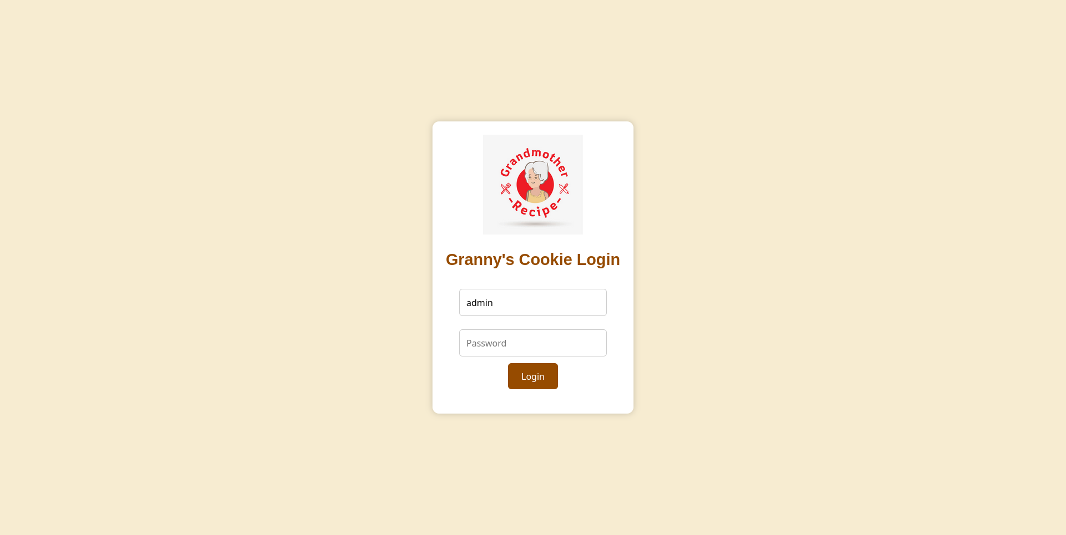

Step 2: Granny has lost her credentials , maybe they are somewhere hidden in the website.

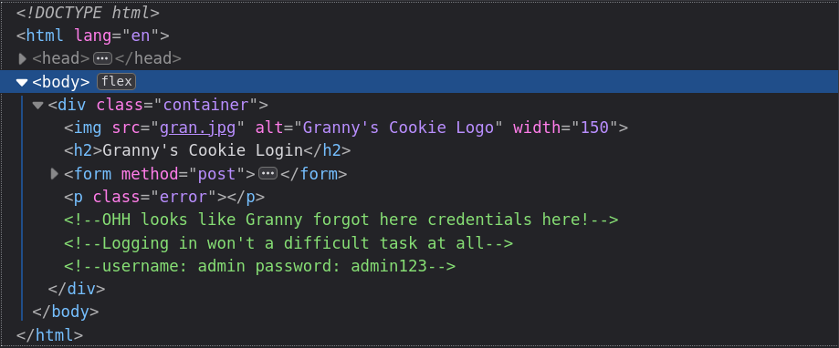

Step 3: We have found the credentials, let’s test them out.

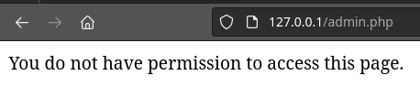

Even with the right credentials we do not get access to the web page?

Step 4: Let’s check the requests by intercepting it through Burpsuite.

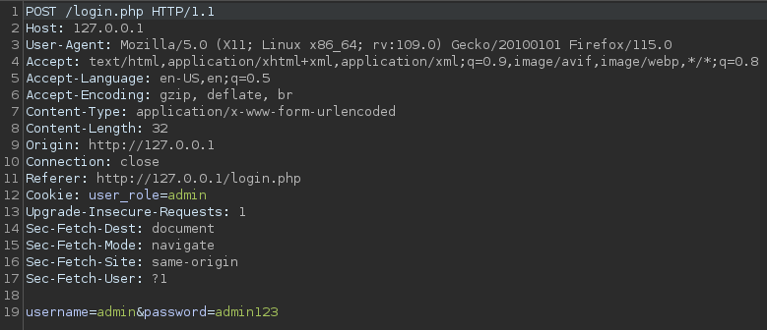

Even the cookies are set correct, so what is the issue here?

Wait, let’s remember the description:

The “head of the family”, Granny lost her credentials. Granny is a type of admin(head) , right?.

Step 5: Let’s change “admin” to “granny” in both the request.





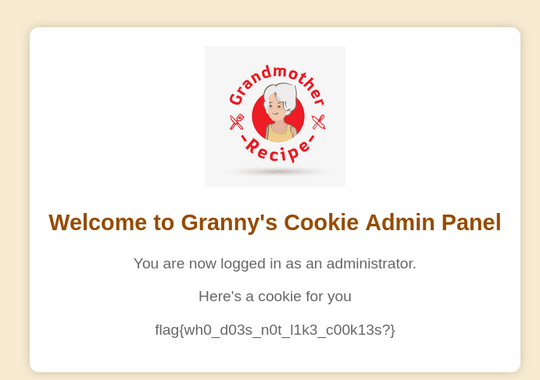

We are granted access and we have found the flag!!

This page is intentionally left blank